

Rules Summary

Action Turn
Defender (or Difficulty) Sets the Stakes.

Turn Order
- The person who acted first picks the person to go next, and then that person does so, until everyone has acted. The last acting character can choose anyone to go first (themselves or another) at the beginning of the round. Repeat until the action is resolved.

Create Dice Pool
- Roll Dice and add together the Top Two Dice. Set aside Ones (Jinxes).
- Spend Plot Points to add one more die from your pool to the total.

Raise the Stakes
- Attacker (or Actor) Raises the Stakes.
- Create Dice Pool as described above.

Big Damn Hero Dice
- If either side has a Big Damn Hero Die they can spend a plot point to roll it and add to total.

Resolving Action
- If Attacker's total exceeds Defender's total, then they have Raised the Stakes.
- Failure= Attacker Taken Out.
- Success = Defender Taken Out.
- Success by 5 = Extraordinary Success (get a Big Damn Hero Die = the highest rolling die in opponent's pool).

All Ones (Botches & Opportunities)
- If all dice rolled are a Ones you botch. Ones rolled by the GM are Opportunities.

Taken Out & Complications
- If a person accepts being Taken Out, they cannot contribute to the action any more.
- Alternatively, they can spend a Plot Point to get a Complication = Highest die in opponent's pool, and stay in the action. Multiple complications can Step Up the complication. When a complication is Stepped Up past d12 the person is Taken Out.
- Determine any Complications from either avoiding being Taken Out or from Jinxes.

Player Dice Pool

Starting Dice
A Player always gets dice from the:
- Appropriate Attribute.
- Appropriate Skill.

Additional Dice
In addition players can add the following dice:
- Specialty d6 (if appropriate).
- Distinction Dice (d4 or d8) Distinctions might also change your dice pool or give you other options.
- Signature Assets (d6 or d8),
- Assets created for the scene or episode,
- Opponent's Complications.

Get Plot Points:
- Start with One each episode.
- You activate a Distinction Trigger, such as rolling a Distinction as a d4 instead of a d8.
- The GM buys a Complication after you've rolled a jinx.
- The GM spends a Plot Point on a roll opposing your character.
- The GM decides you deserve one for roleplaying such as a great play, a snappy one-liner, or a scene description that impresses your Crew.

Spend Plot Points
- Keep an additional die from your dice pool in a total after your roll.
- Activate a Distinction trigger (if required).
- Create an Asset at a d6 that lasts until the end of the scene.
- Make an existing Asset last until the end of the Episode.
- Roll a Big Damn Hero Die and add the total to your total after you roll.

Help Another Player
- Add one of your dice to another player. Jinxes can still apply.

GM Dice Pool

Major GM Characters
- Attribute.
- Skill.
- Trait die representing the situation or location.
- Distinction or Distinction trigger.
- Signature Asset.
- Complications that work vs. the player.

Difficult Action (or minor GMCs or Extras)
- Difficulty die.
- Trait die representing the situation or location.
- Minor GMC or Extra die.
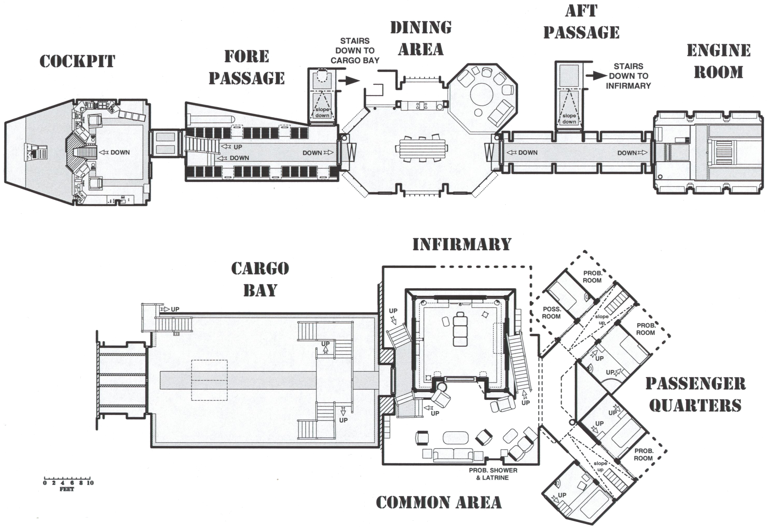
- Complications that work against the player.

GM Plot Points
- Include additional dice in the total during an Action.
- Activate a Distinction trigger for a Major GMC.
- Buy a d6 Complication (or higher) when a player rolls a jinx.
- Upgrade a Complication when a player rolls a jinx.
- Reward players for great moments.

Glossary
- Big Damn Hero Die = After rolling an extraordinary success bank the die type of the highest roll in the opponent's pool. Spend a Plot Point to add it to the total of any roll.
- Set the Stakes = Roll dice to determine target number.
- Raise the Stakes = Roll dice and equal or exceed the stakes.
- Jinxes = Natural Ones rolled in a pool.
If a player rolls them the GM can purchase them for a plot point and give a d6 ( or step up) a complication.
If the GM rolls them. it is an Opportunity. The player can purchase an opportunity to step back a complication.
- Botch = Roll all ones = Taken Out AND some consequences.
- Step Up = Raise a die one type (d6 to d8, etc.).
- Step Back = Lower a die one type (d8 to d6, etc.).
- Taken Out = No longer able to affect the action or combat.

To Do
- Add healing Rules (rolling vs. complications)
- Add Difficulty Level
CREDITS: by Stan Shinn, adapted from https://goo.gl/ZYJjZf. Contact stanshinn@gmail.com for questions or comments.

Overview

The Basic Roll
Characters have various traits – mostly commonly Attributes (mental, physical, social), Skills, Distinctions, and Assets – and each of these traits has a die rating (d4, d6, d8, d10, d12). When taking an action, the player rolls dice (at least two for Attribute and Skill, possibly 10 or more if there are a whole mess of things going in the character’s favor) and then adds the two highest together. This roll (called raising the stakes) must exceed the total rolled by the GM for the NPC involved (the GM’s roll is called setting the stakes, is produced in a similar fashion, and is rolled first). If the PC is on the defensive, then the order will be reversed – the PC sets the stakes, and then the NPC must raise the stakes. Any die that comes up a 1 is a jinx – it can’t be added to your total (even if this leaves the character with zero or one die), and might saddle the PC with Complications. All ones is a botch, and I think we can all safely assume that’s a Bad Thing for the PC.

Plot Points
Each player starts each game session with one plot point, but there are several ways to get more. Pretty much all of the Distinctions (more on those later) can give out plot points. If a PC rolls a Jinx, the GM can give the PC a plot point to create a Complication (more on those in a moment). And the GM can hand them out if the player is awesome in some fashion. Plot points are quite versatile, and can be used to activate certain Distinction abilities, create an Asset that lasts until the end of the scene (or for the rest of the episode, for two plot points), add a third or subsequent die to the die roll (chosen after knowing the roll and possibly after knowing the target number, so a very potent function), or not getting Taken Out.

Assets
Assets are any random thing that the player can come up with that has some positive relation to the activity. Normal assets are created temporarily by spending plot points. Signature Assets are permanent, appearing on the character sheet and getting used whenever applicable (Signature Assets can also have abilities like Distinctions). Assets can be physical objects, preparation, attitudes, or relationships. So, for example, Malcolm Reynolds might have the Serenity as a high-level signature asset – any time he makes any roll that has to do with the Serenity, he gets to roll an additional d8. Or Zoe and Wash might have assets that give them extra dice to roll when they’re working together. Kaylee might have an easier time convincing someone she’s innocent of a crime because she’s so gosh durn cheerful and sweet. And so on. The only limitations on adding dice from Assets are how many plot points are on hand and how much the GM will let the player get away with.

Complications
Complications are something like anti-Assets – they’re something the character is saddled with that gives the opposition an extra die when it comes into play (and the PCs may get to add Complication dice to their pools when the NPCs have Complications). Whenever a PC rolls a Jinx, the GM can give the PC a plot point to inflict a Complication (the more jinxes, the nastier the Complication). A character may also have been saddled with Complications in order to stick around in a confrontation rather than being Taken Out. Complications can be worked off – there are recovery rolls, and PCs can spend plot points to reduce or remove Complications whenever an NPC rolls a 1.

High Stakes Rolls and Getting Taken Out
The GM may determine that a roll is high stakes for one or both of the characters involved. If a roll is high stakes for a character, then losing the roll means that the character will be Taken Out for the rest of the scene. The most obvious example of a high stakes roll is combat, but there can also be social rolls that invoke this rule (e.g., the character is humiliated and cannot meaningfully socially spar any more that night). By default, this is still a single roll – so, unless one of the combatants wants to extend the fight, even combat is a one-roll affair. But characters with plot points available (and who are not hopelessly overmatched) will likely want to stay in the fight a little longer. A character can spend a plot point and taken a complication (typically a wound, for a combat action) to keep on rolling. This makes the next roll worse for the character, but at least she’s still got a shot! Well, for a little bit anyway – eventually one of the complications she’s been saddled with will be too much, and will Taken her Out anyway.

